Week 2
IICT Lab

LAB # 2: Introduction to MS Word

- Beginning in Microsoft Word
- Opening Microsoft Word:
To open Microsoft Word, click on the Start Icon and write Word, click the app.
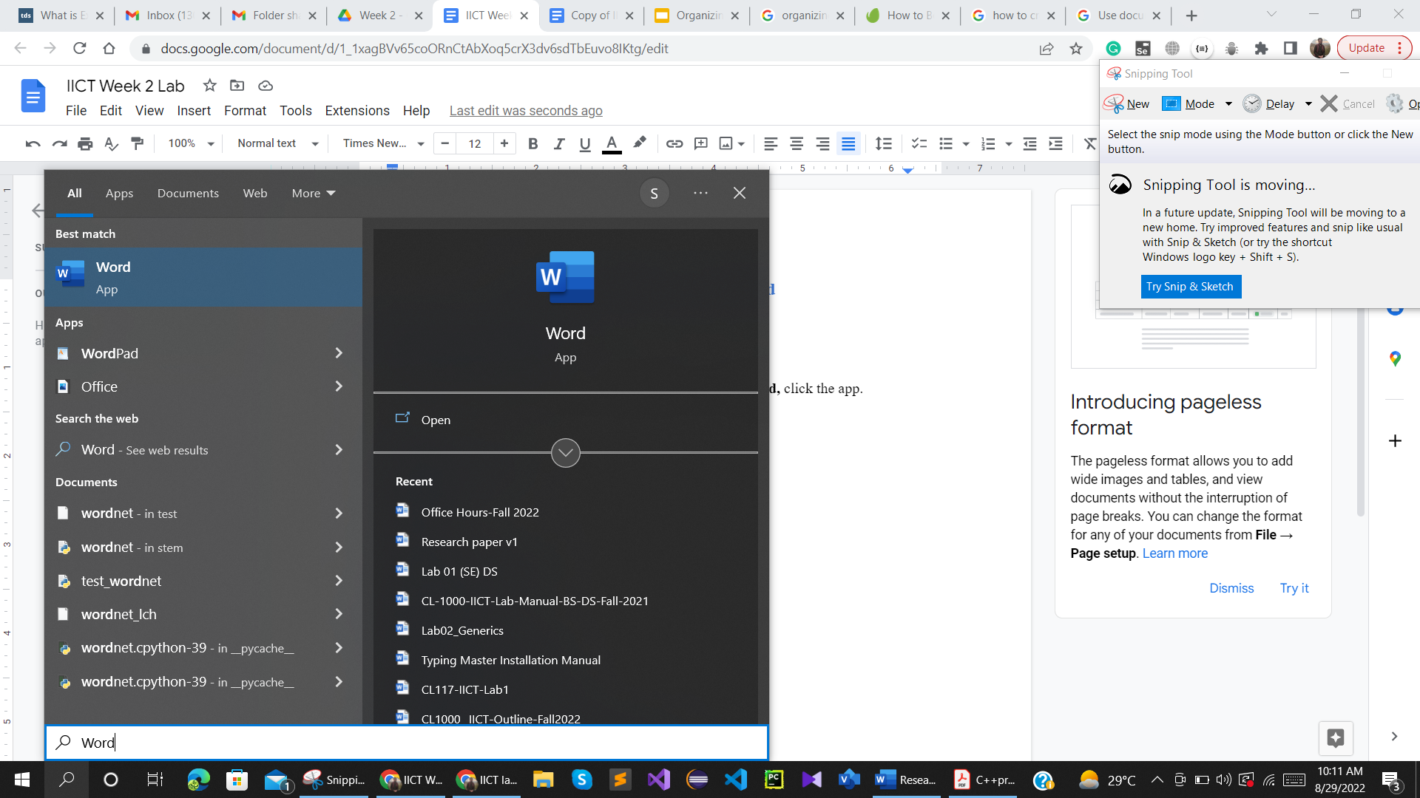

Once, MS word is opened then click on the Blank document at the top of the screen.
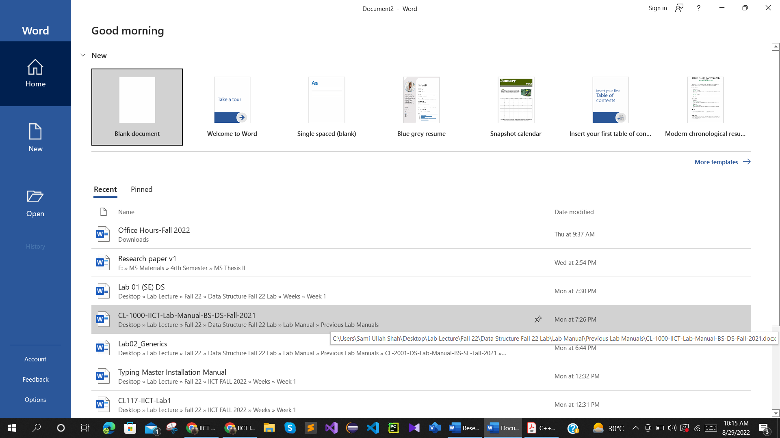
After clicking the Blank document, your window will look like the screenshot below
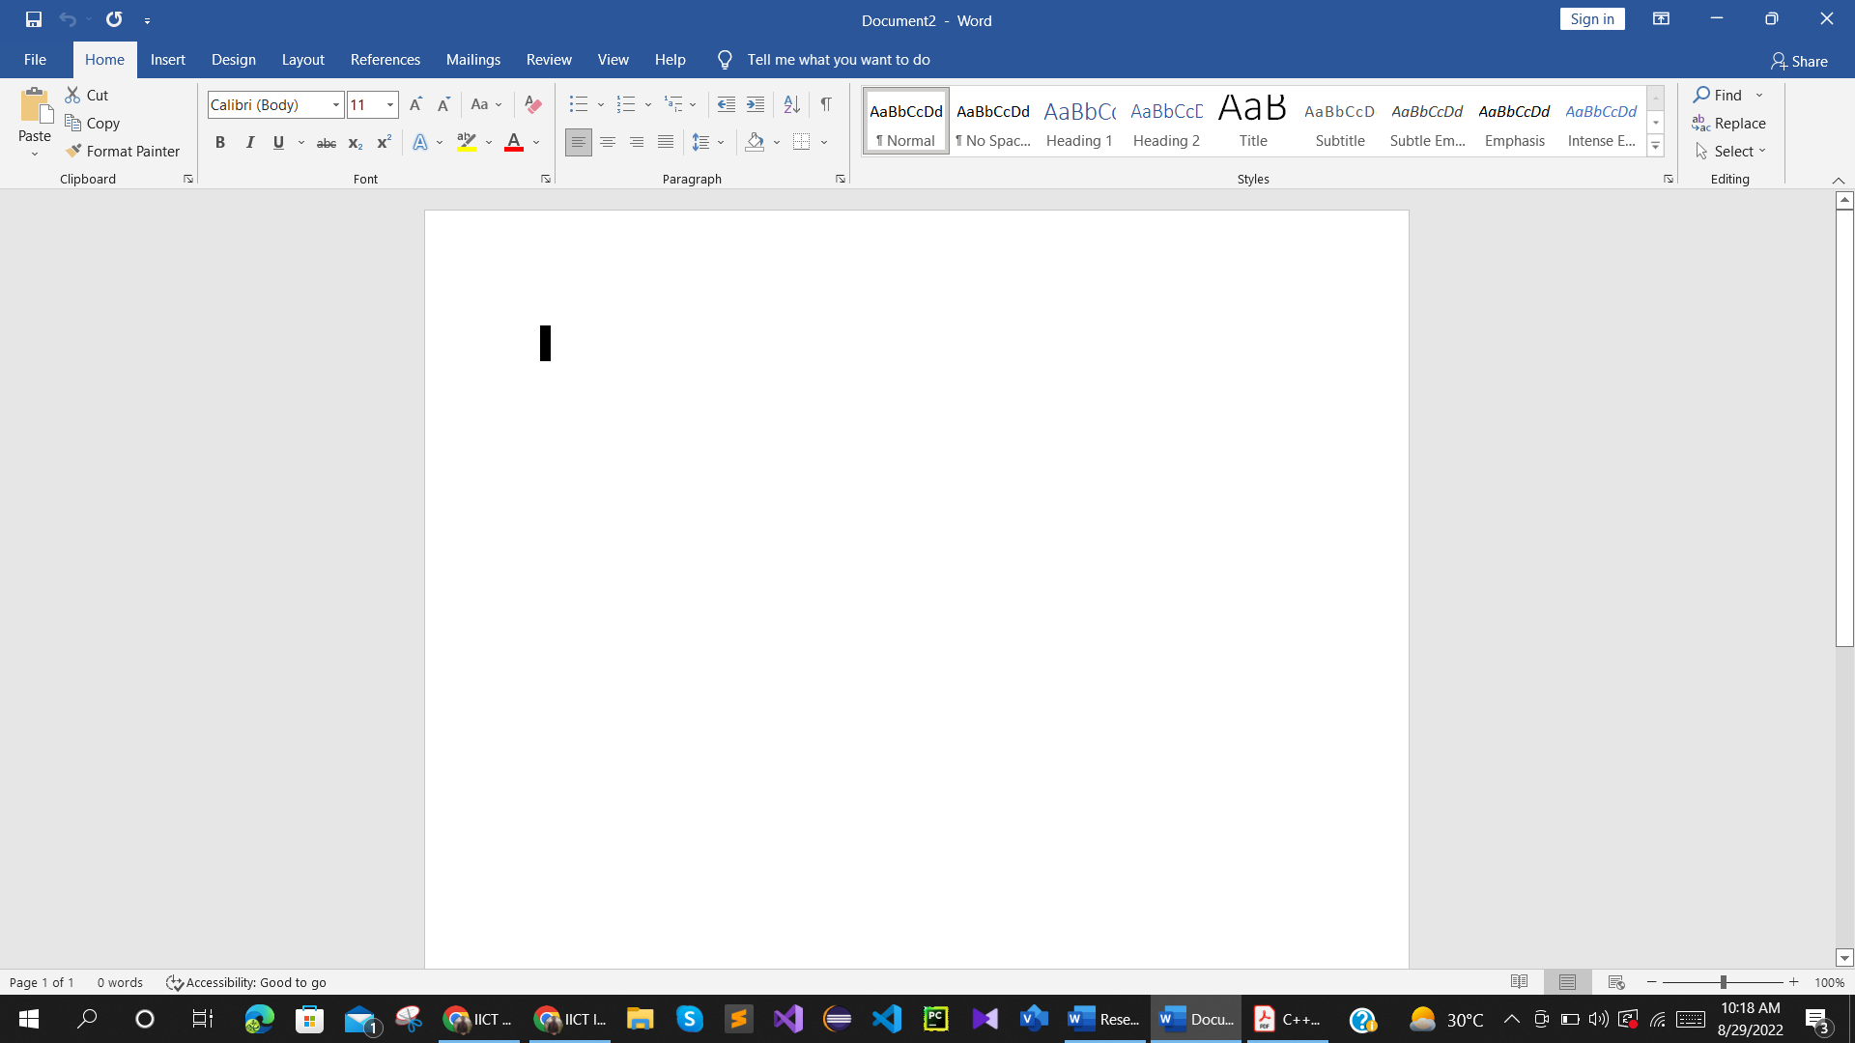

- Title bar
This is located at the very top of the screen. On the Title bar, Microsoft Word displays the name of the document you are currently using. At the top of your screen, you should see "Document1" or a similar name.

- Quick Access Toolbar
On the far left is the Quick Access Toolbar. The Quick Access Toolbar is a customizable toolbar that contains commands that you will probably use frequently. You can place the Quick Access Toolbar above or below the ribbon. To change the location of the Quick Access Toolbar, click on the arrow at the end of the toolbar and click on Show Below the Ribbon. You can also change the icons within the toolbar by clicking on various commands within the dropdown.
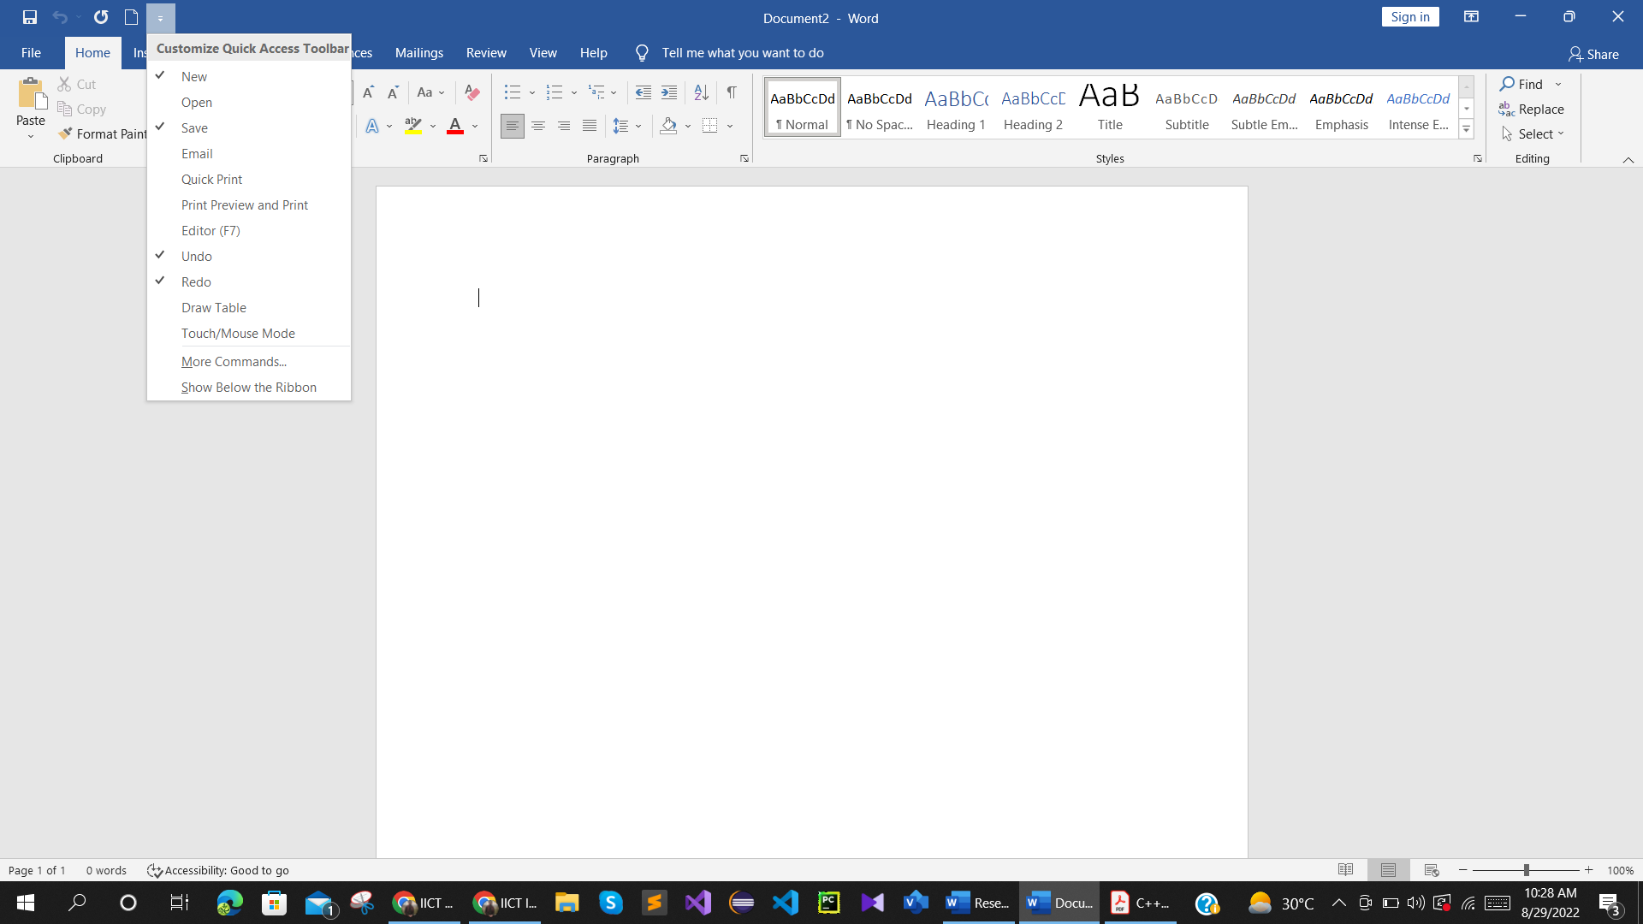

- The Ribbon
The Ribbon is located underneath the Quick Access Toolbar in the top portion of the document. It has eight tabs: File, Home, Insert, Design, Layout, References, Mailings, Review, View and Help that contain many features of Word. Each tab leads to a new ribbon which is divided into groups. The groups are logical collections of features designed to perform functions that you will utilize in developing or editing your Word document. Commonly used features are displayed on the Ribbon. To view additional features within each group, click on the arrow (Dialog Box Launcher) at the bottom right of each group.
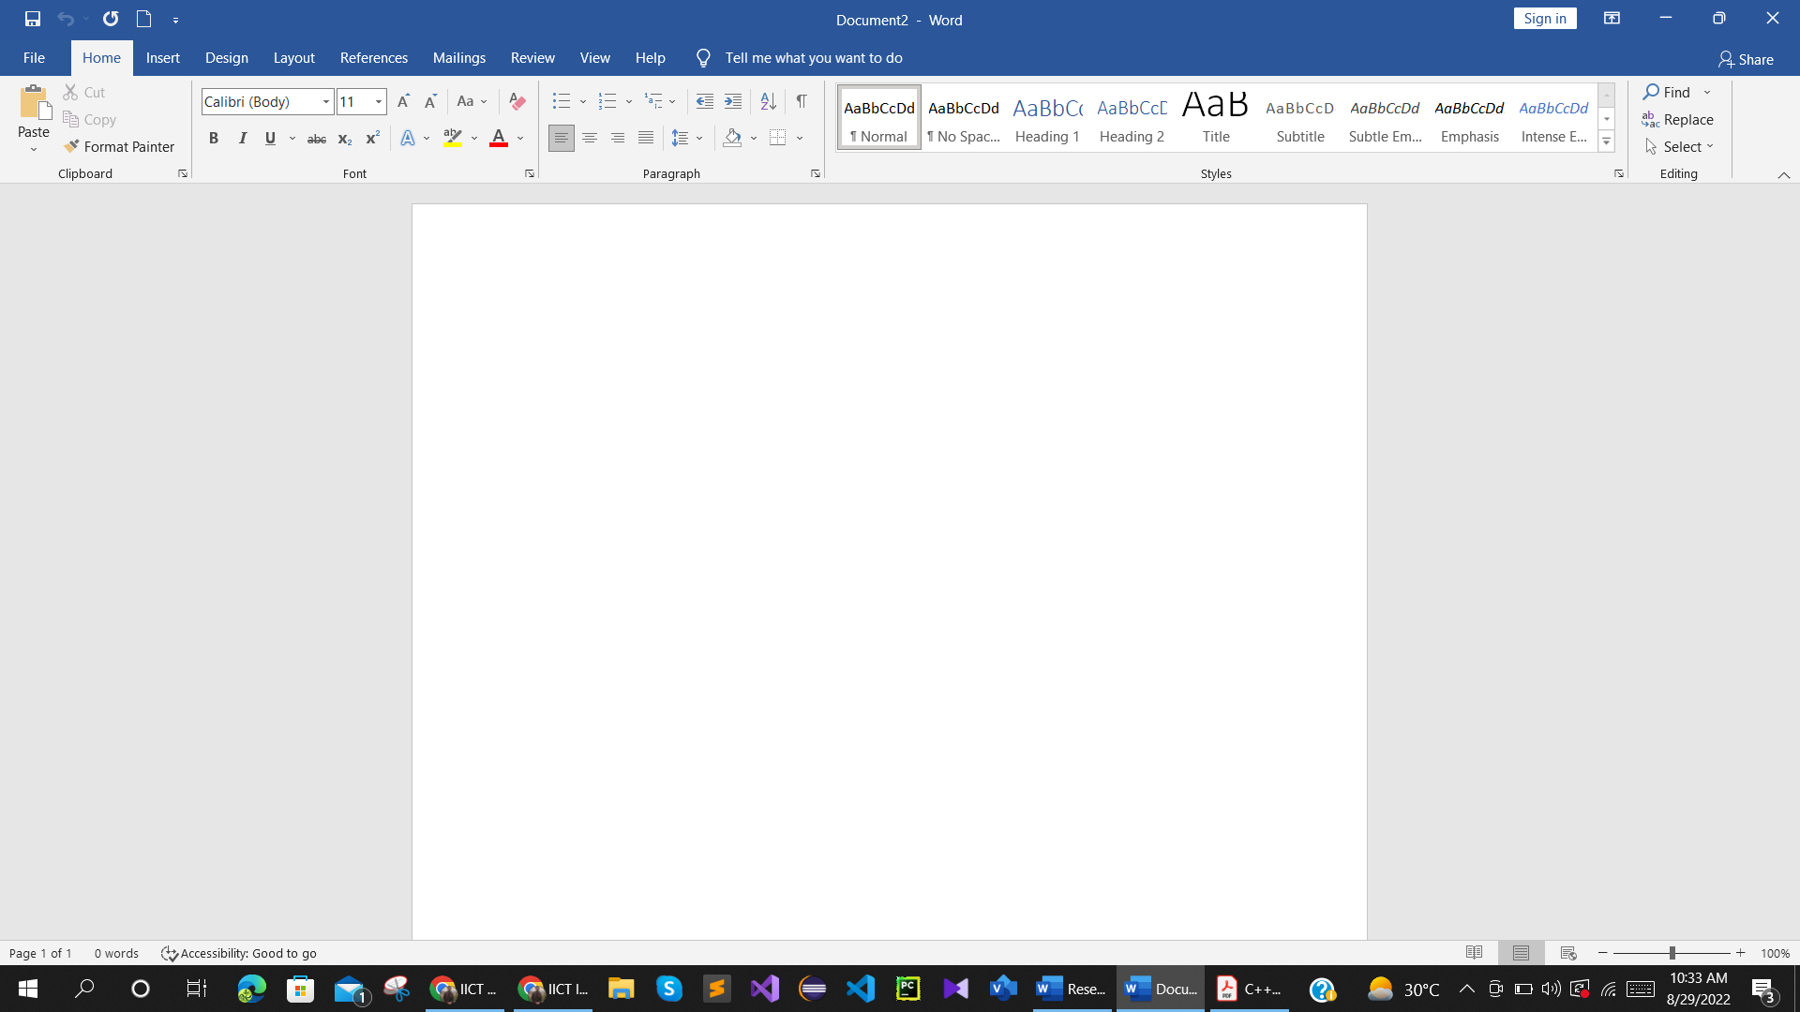

- Status Bar
This bar appears at the very bottom of the screen and provides such information as the current page, current section, total number of pages, inches from the top of the page, current line number, and current column number. There is also a Zoom Slider at the right end of the Status bar which can be easily manipulated to change the size of the document as you view it. It does not affect the actual size, only the way you look at it on the screen. All of these options can be accessed by right-clicking on the Status bar.

- Defaults
The standard font for Word is Calibri, 11 pt. This is a change from prior versions of Word. It is possible to change the default font.



- Typing and Inserting Text
To enter text, just start typing! The text will appear where the blinking cursor is located. Move the cursor by using the arrow buttons on the keyboard or positioning the mouse and clicking the left button. Text will automatically wrap to the next line; if you want to start a new paragraph, hit the Enter button.

- Undo and Redo
You can quickly undo most commands you execute by using Undo. If you then change your mind, you can use Redo. This can be done quickly and easily by using the backspace button that above the Enter button.

- Formatting Text
- Creating new Documents
To create a new document, click the File tab and then click New. Clicking on New opens up a huge assortment of templates available both on the computer and from Microsoft online. To start from a blank document, click Blank.
Moreover, type =rand(5, 5) and press Enter.

- Selecting Text
In order to change anything about text once you have typed it in, the text must be highlighted. Select the text by dragging the mouse over it while holding down the left mouse button or hold down the SHIFT key on the keyboard while using the arrow buttons to highlight the text. The following table contains other shortcuts for selecting a portion of the text:

Selection | Technique
Whole Word (Entire Document | Press ctrl + a.
Line | Click in the left margin next to the line you want to select.
Whole Paragraph | Double click the right mouse button.
Several words or lines | Drag the mouse over the words, or hold down SHIFT while using the arrow keys.

- Saving and Closing a document
In order to find your file later, you must save it. If you are saving a file that has not been saved before, the Save As dialog box appears automatically when you click Save. Click options in the Save As dialog box to save a file to a file name, format, and location that you specify. After you save a document, when you click Save, the file will automatically save without a dialogue box coming up. If you want to save the file with a different name or to a different location, you must choose Save As and specify the new information when the dialogue box appears.
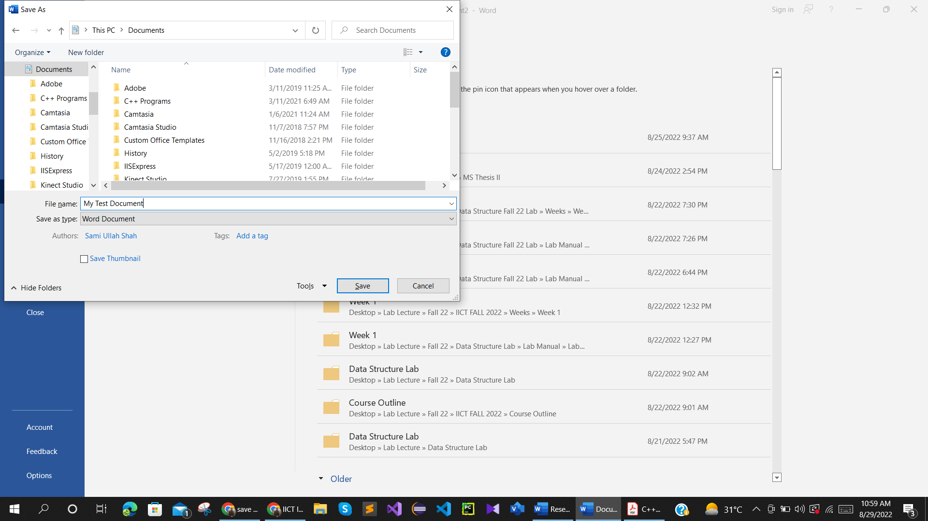

- The Insert Tab: Enhancing your document

The Insert Tab comes second as an option to enhance the document you are working on. Note depending on what you are doing, there is another tab that shows up referenced as Contextual Tools (tools that show up in the context of what you are doing). Take note of the Styles area for each scenario.
- Inserting Pictures
Pictures can be inserted into documents
- Click on Insert > Pictures > Browse for the Picture > Modify the picture by using the Format Tab / Styles on the Ribbon
- Click Insert > Online Pictures > Search for the Picture > Select the Picture > Click on Insert > Modify it using the Format Tab.
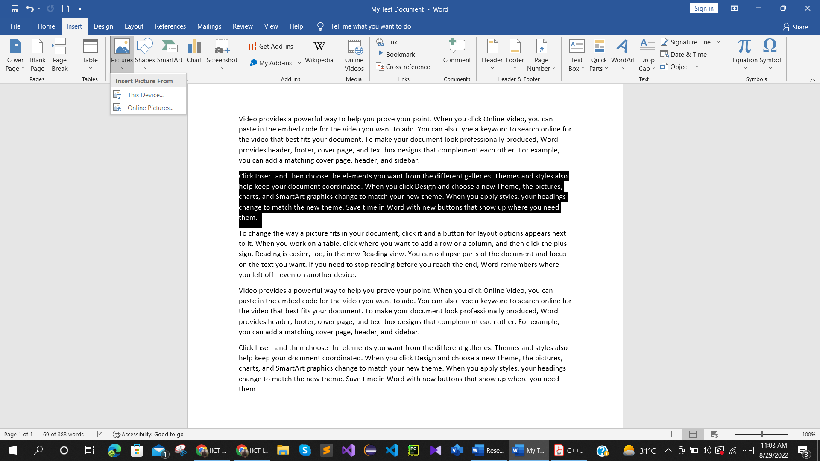

- Inserting Shapes
Shapes can be inserted into document through
- Click on Insert > Shapes > Select Shape.
- Draw object on the screen by holding down the mouse > Modify object by using the Format Tab.
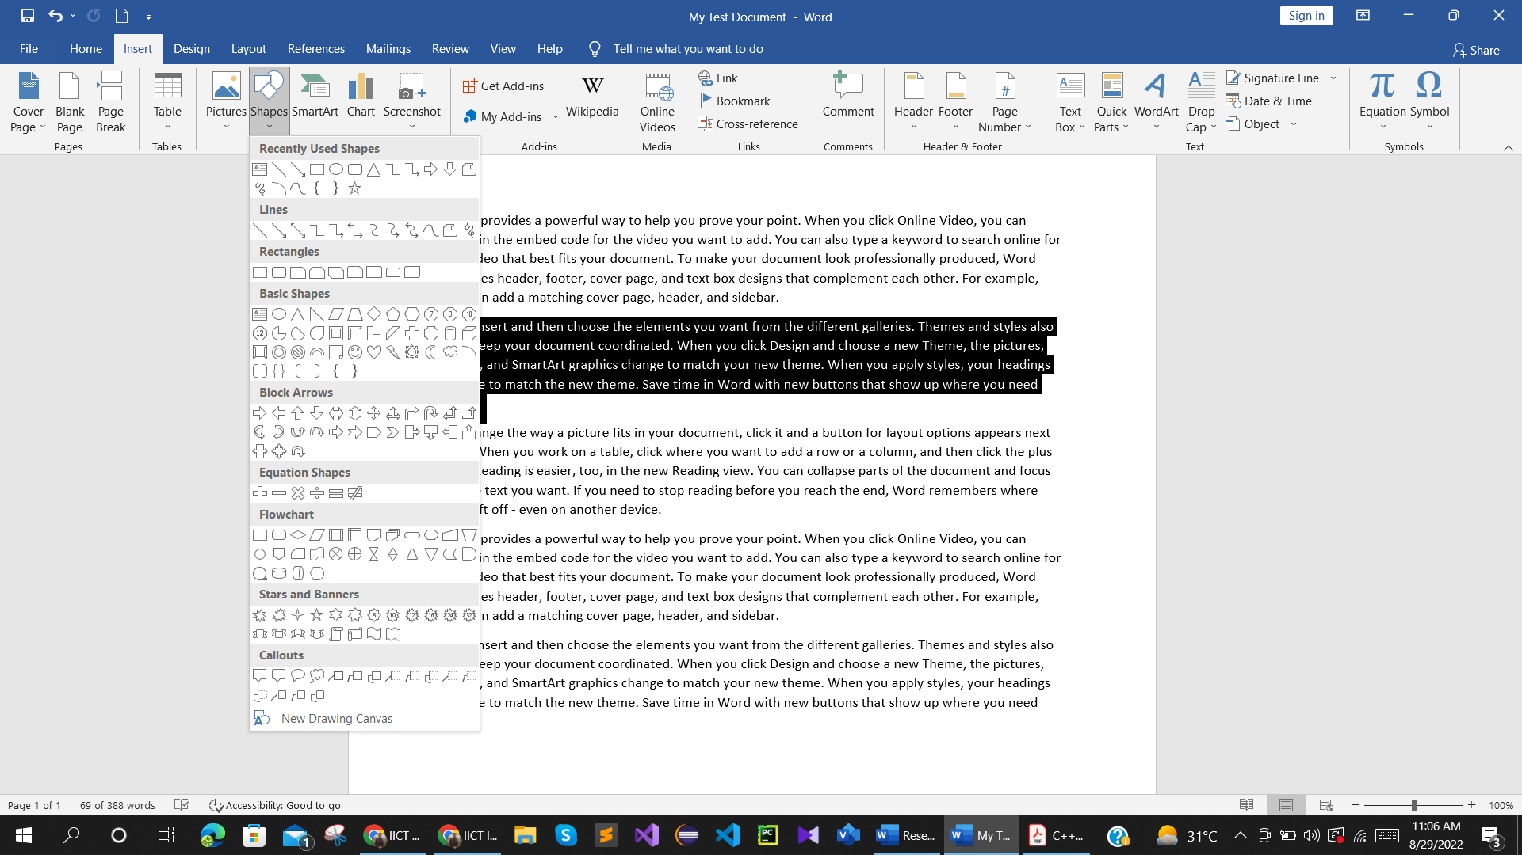

- Inserting Smartart
- Click on Insert / SmartArt / Select a design / OK
- Type the items on the left as typing bullet points / Format it using the Format and Design Tabs on the Ribbon.
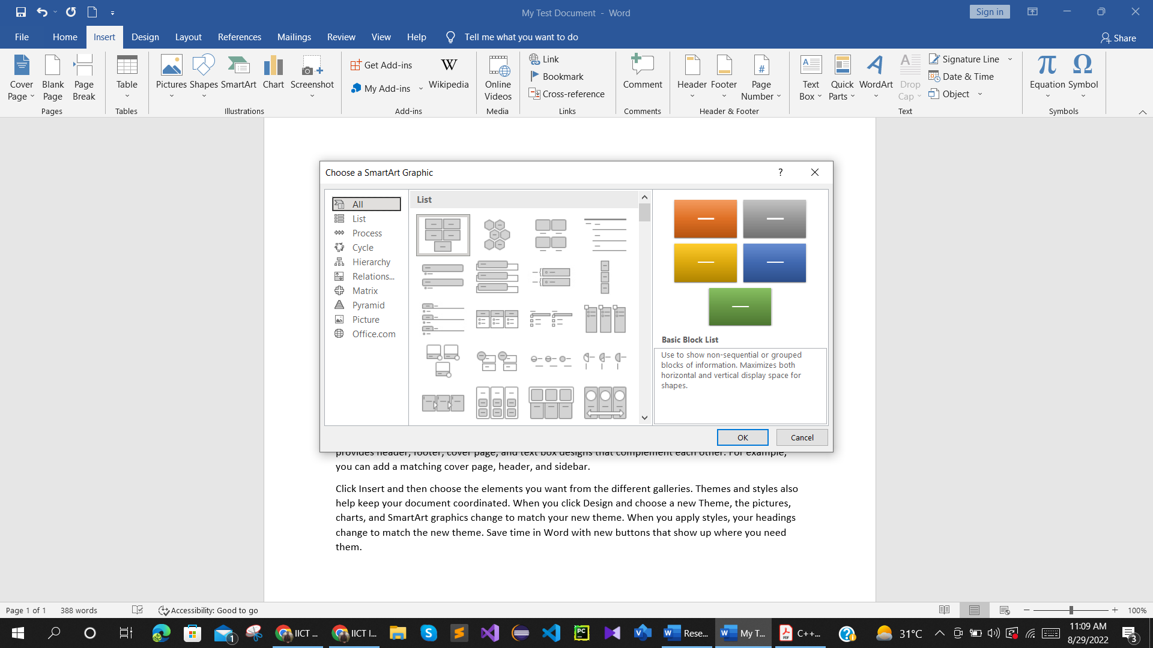

- Inserting Tables
Click on Insert / Table / Select the Number of Columns and Rows
2. Note the Contextual Tools with 2 tabs on the Ribbon: Design and Layout
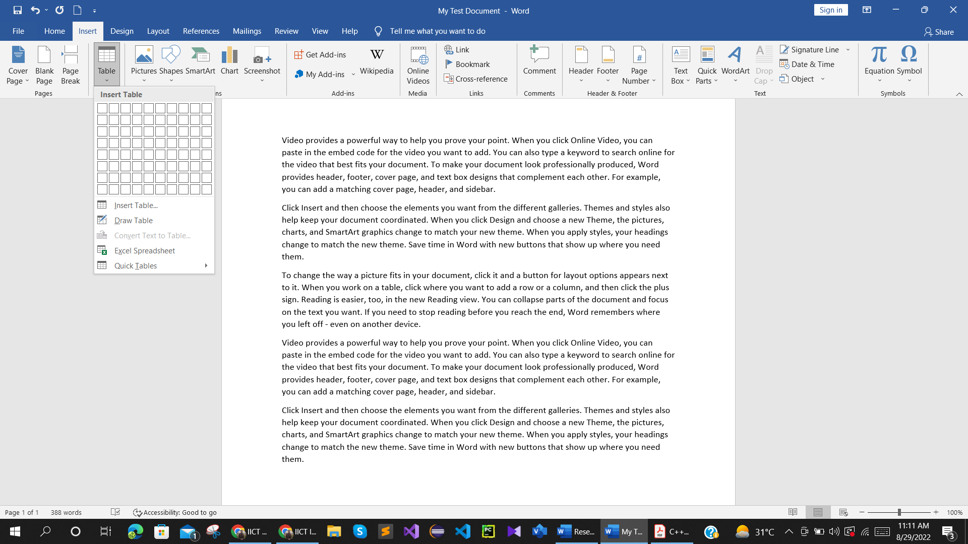

- Inserting Charts
- Click on Insert / Chart / Pick a Desired chart design and click OK.
- Change the data in the spreadsheet like window. Read just the selection in blue to customize the desired data area. Close the data area when done.
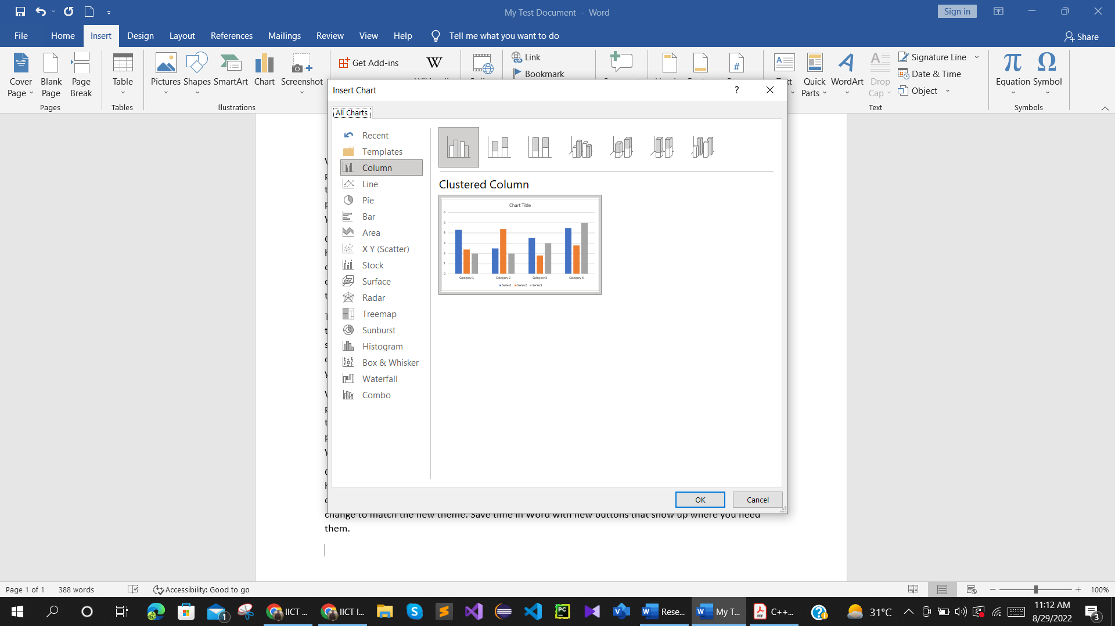
- Inserting Headers and Footers
- Click on Insert / Header or Footer / Choose one of the designs
- Type the content of the header or footer / use Header & Footer tools on the Ribbon
- Double click on the header or footer area to re-tweak it.
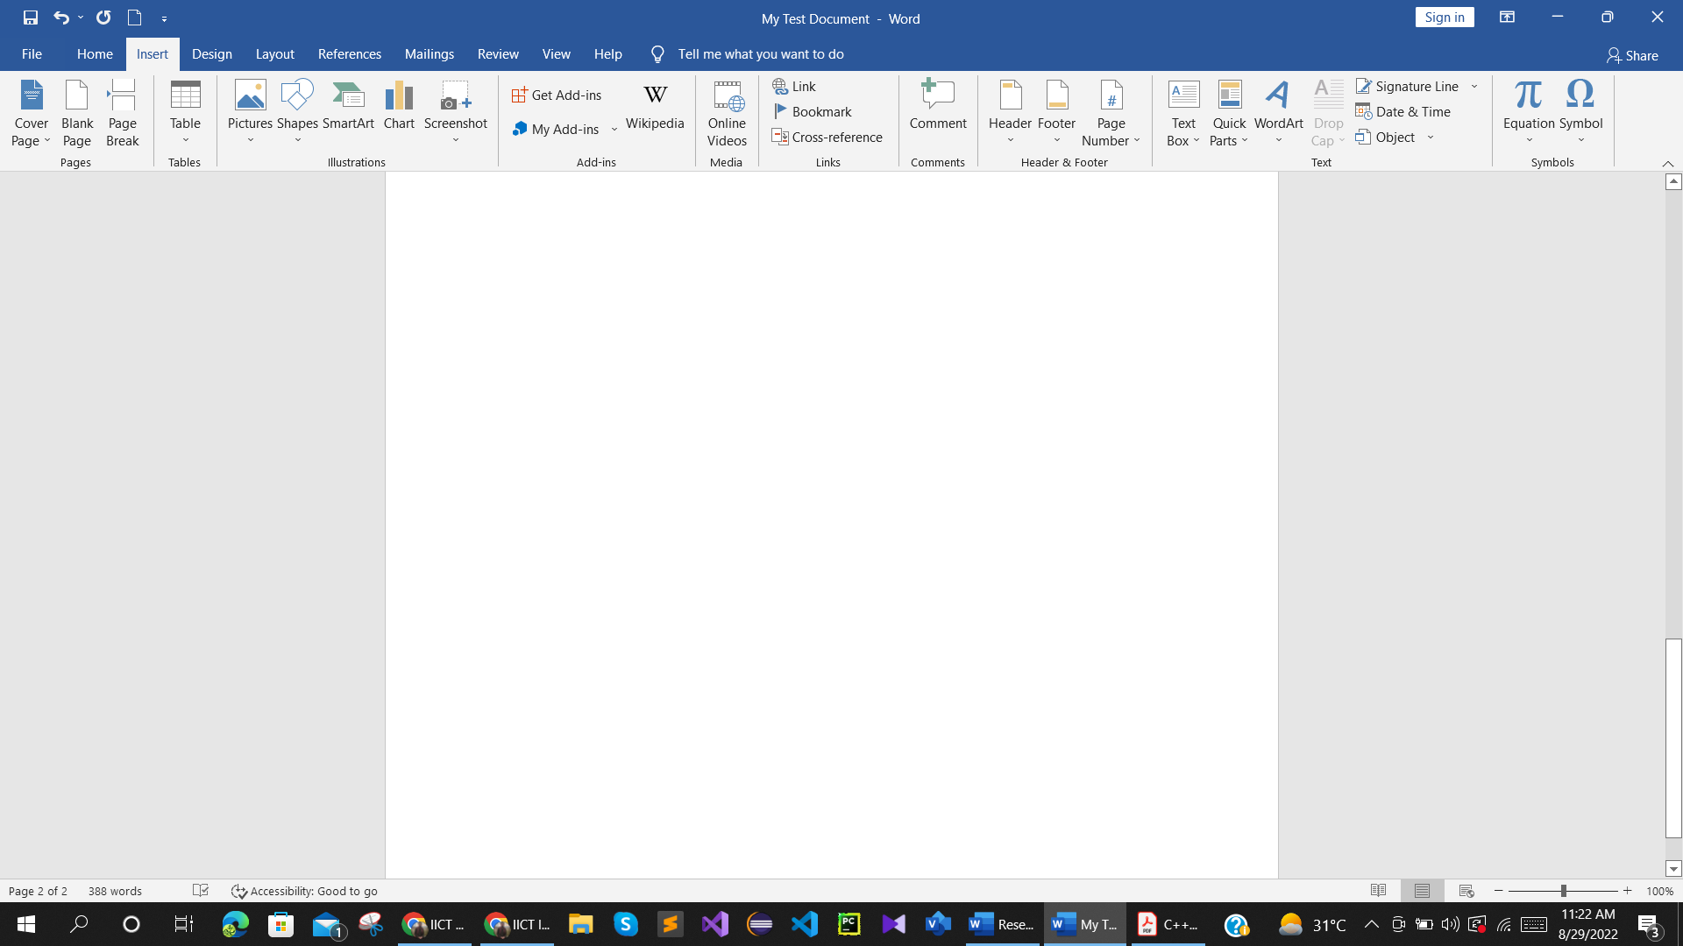
- Documents Formatting: Changing the Margins
The layout is basically tweaking the margins, orientation, size, columns, positioning and text wrapping.
- Open an existing document and Click on Layout Tab and Choose Margins.
- Select from one of the existing layouts e.g., Narrow or to further customize it, choose Custom Margins.
- Tweak the settings as desired. Note the additional options at the bottom of the window and the tabs. Moreover, Set as Default which tells the computer that you want the default for any new documents to have that settings.
1. Open an existing document and Click on Layout Tab and choose Margins
2. Select from one of the existing layouts e.g. Narrow or to further customize it, choose Custom Margins.
3. Tweak the settings as desired. Note the additional options at the bottom of the window and the tabs. Note also the Set as Default which tells the computer that you want the default for any new documents to have that setting.
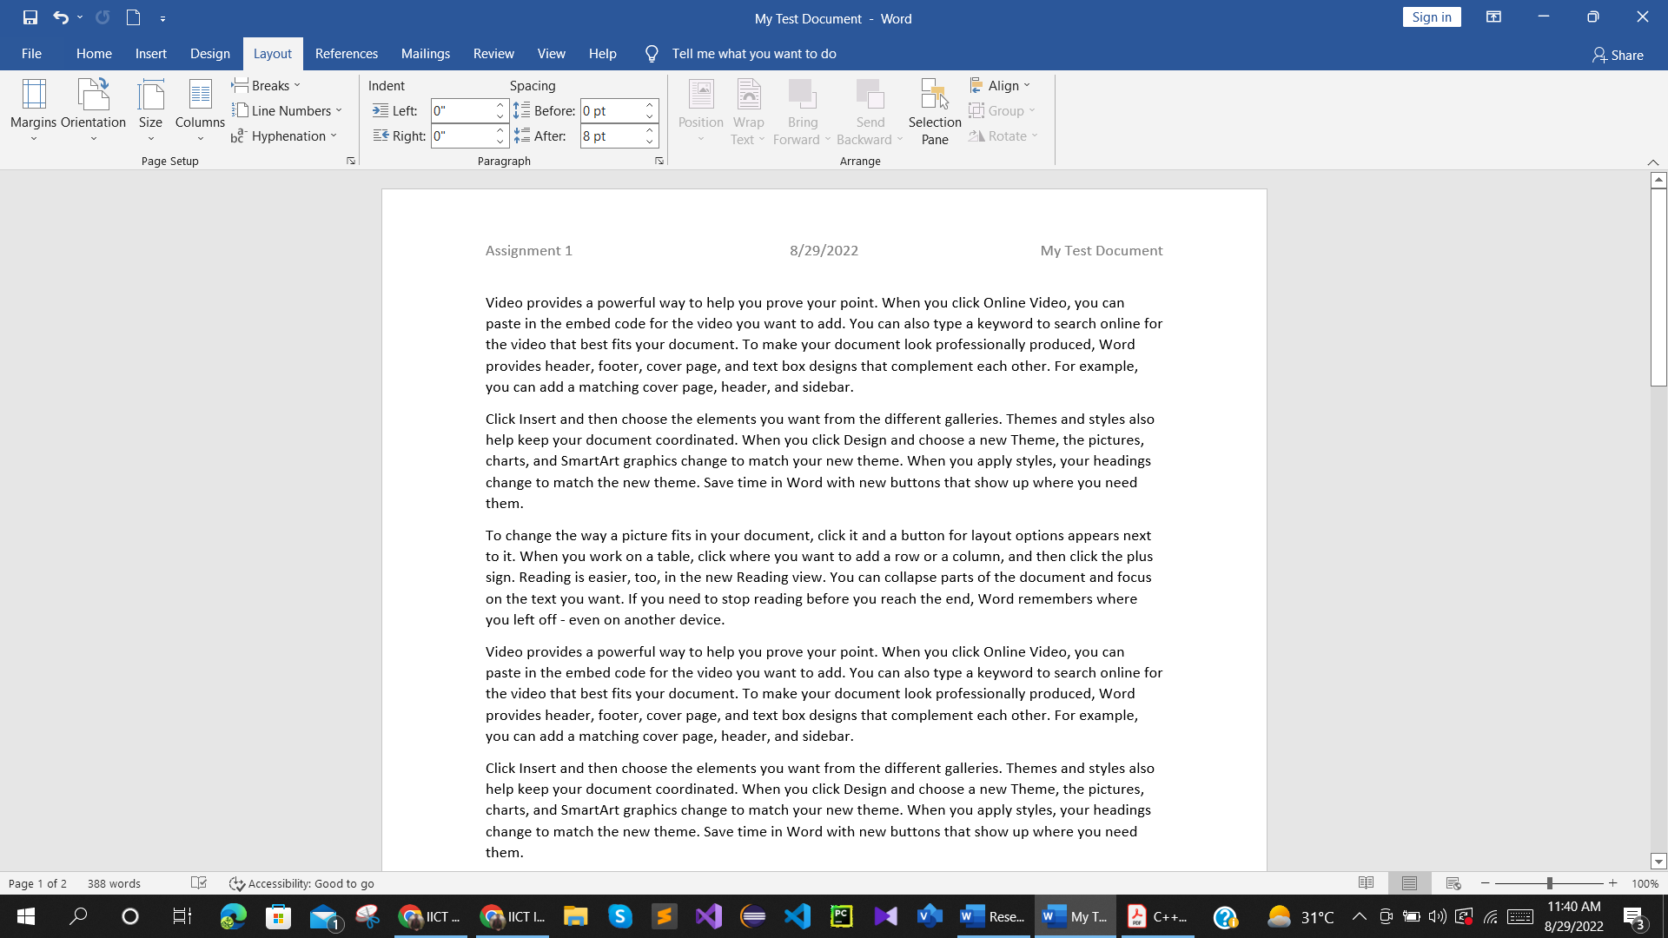

Inserting Columns
Follow the each steps mentioned below
- Open an existing document and Click on Layout Tab and choose Columns and Select from one of the options.
- Note that the whole document will be converted into two or more columns depending on what you selected. To apply columns to a particular area do the following:
- Select the text that you want in columns, click on Columns and select how many you want to apply. To further customize columns use the advanced settings by clicking on Columns and selecting More Columns. Note the Apply to section.
If you want to add more columns
- Click anywhere you want to start columns in the document
- Click on Page Layout / Columns / More Columns / Choose Number of Columns / Line in Between / Choose Apply to…: / OK.
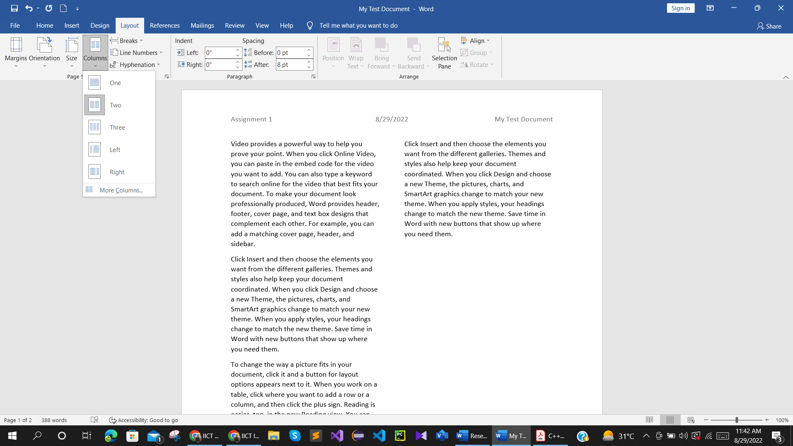

Lab Task:
A sample newsletter has been given below. You are required to make a copy of it by ensuring the completion of all the below mentioned points in your task.
- You must insert your data in columns as shown.
- Addition of an image is must.
- Text should be properly formatted. (You can use a different font style)
- Margins of the page should be given properly.
- Create borders around the newsletter.
- Add data in bullets in the last section under heading “Location based social media” instead of paragraphs.
Note: You are allowed to insert dummy data where required.

Submission Guidelines:
- Save your document with the naming convention Name_RollNo_Section.docx and upload on google classroom.
